**Module 4 Analytic Queries (Capstone Project)**

1. **AQ1**

SELECT Location_Name,Time_Year,Time_Month,SUM(Quantity_Ordered*Unit_Price) AS AMT,

SUM(SUM(Quantity_Ordered*Unit_Price)) OVER (Partition by Location_Name,Time_Year Order By Time_Month ROWS UNBOUNDED PRECEDING) AS CUMSUMAMT

FROM W_JOB_F,W_LOCATION_D,W_TIME_D

WHERE W_JOB_F.Location_ID = W_LOCATION_D.Location_ID

AND W_TIME_D.Time_id = W_JOB_F.Contract_date

GROUP BY Location_Name,Time_Year,Time_Month; (388 rows)

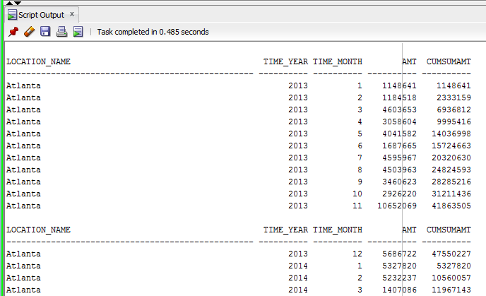

1. **AQ2**

SELECT Location_Name,Time_Year,Time_Month,AVG(Quantity_Ordered*Unit_Price) AS AVGAMT,

AVG(AVG(Quantity_Ordered*Unit_Price)) OVER (Partition by Location_Name Order By Time_Year,Time_Month ROWS 11 PRECEDING) AS AVGSUMAMT

FROM W_JOB_F,W_LOCATION_D,W_TIME_D

WHERE W_JOB_F.Location_ID = W_LOCATION_D.Location_ID

AND W_TIME_D.Time_id = W_JOB_F.Contract_date

GROUP BY Location_Name,Time_Year,Time_Month;

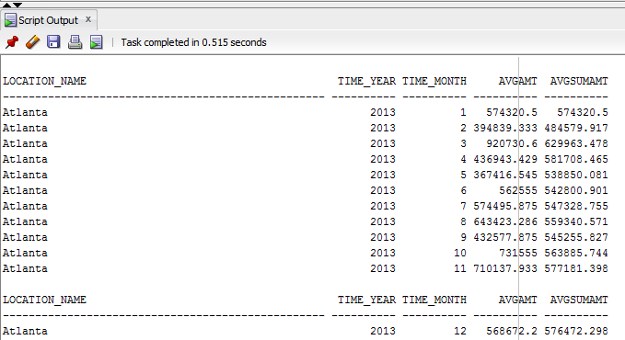

1. **AQ3**

Select BQ2.Location_Name,BQ2.Time_Year,BQ2.Time_Month,SUM(SUMINVAMT - TOTALCOST) AS Profit,

RANK() OVER(Partition By BQ2.Time_Year Order by SUM(SUMINVAMT - TOTALCOST) DESC) AS Rank

FROM BQ2,BQ3

WHERE BQ2.Job_id = BQ3.Job_id

GROUP BY BQ2.Location_Name,BQ2.Time_Year,BQ2.Time_Month;

(312 rows)

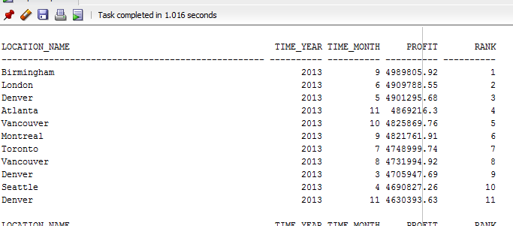

1. **AQ4**

Select BQ2.Location_Name,BQ2.Time_Year,BQ2.Time_Month,SUM(SUMINVAMT - TOTALCOST)/SUM(SUMINVAMT) AS ProfitMargin,

RANK() OVER(Partition By BQ2.Time_Year Order by SUM(SUMINVAMT - TOTALCOST)/SUM(SUMINVAMT) DESC) AS Rank FROM BQ2,BQ3

WHERE BQ2.Job_id = BQ3.Job_id GROUP BY BQ2.Location_Name,BQ2.Time_Year,BQ2.Time_Month;

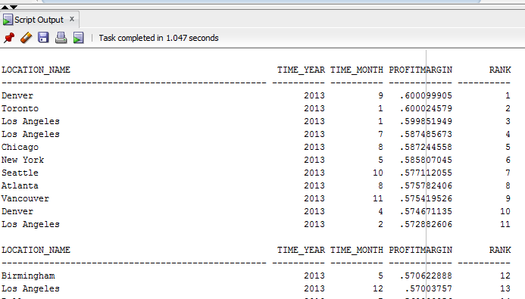

1. **AQ5**

Select BQ2.Job_Id,BQ2.Location_Name,BQ2.Time_Year,BQ2.Time_Month,SUM(SUMINVAMT - TOTALCOST)/SUM(SUMINVAMT) AS ProfitMargin,

PERCENT_RANK() OVER(Order by SUM(SUMINVAMT - TOTALCOST)/SUM(SUMINVAMT) DESC) AS PercentRank

FROM BQ2,BQ3

WHERE BQ2.Job_id = BQ3.Job_id

GROUP BY BQ2.Job_Id,BQ2.Location_Name,BQ2.Time_Year,BQ2.Time_Month; (2504 rows)

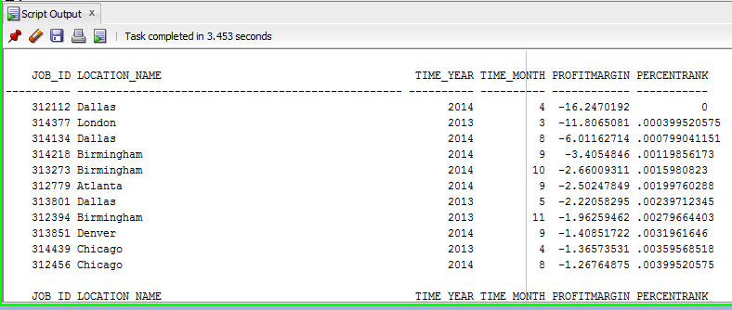

1. **AQ6**

Select *

FROM

(

Select BQ2.Job_Id,BQ2.Location_Name,BQ2.Time_Year,BQ2.Time_Month,SUM(SUMINVAMT - TOTALCOST)/SUM(SUMINVAMT) AS ProfitMargin,

PERCENT_RANK() OVER(Order by SUM(SUMINVAMT - TOTALCOST)/SUM(SUMINVAMT) DESC) AS PercentRank

FROM BQ2,BQ3

WHERE BQ2.Job_id = BQ3.Job_id

GROUP BY BQ2.Job_Id,BQ2.Location_Name,BQ2.Time_Year,BQ2.Time_Month

)

WHERE PercentRank < 0.05;

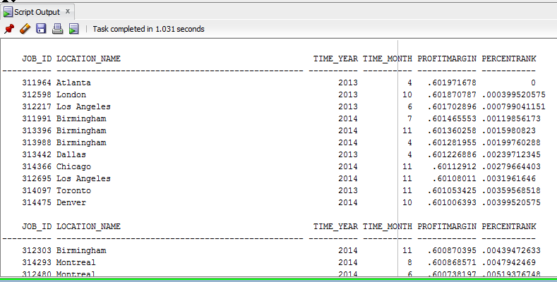

1. **AQ7**

SELECT Sales_Class_Desc,Time_Year,

SUM ( Quantity_shipped - Invoice_Quantity ) as QTYRETURNED,

RANK() OVER(Partition By Time_Year Order By SUM ( Quantity_shipped - Invoice_Quantity ) DESC) AS Rank

FROM W_INVOICELINE_F,W_Sales_Class_D,W_TIME_D

WHERE quantity_shipped - invoice_quantity > 0

AND W_INVOICELINE_F.INVOICE_SENT_DATE = W_TIME_D.TIME_ID

AND W_INVOICELINE_F.Sales_Class_Id = W_Sales_Class_D.Sales_Class_Id

GROUP BY Sales_Class_Desc,Time_Year;

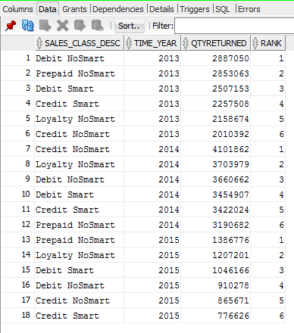

1. **AQ8**

SELECT Sales_Class_Desc,Time_Year,

SUM ( Quantity_shipped - Invoice_Quantity ) as QTYRETURNED,

RATIO_TO_REPORT(SUM ( Quantity_shipped - Invoice_Quantity ))OVER(Partition By Time_Year) AS Ratio

FROM W_INVOICELINE_F,W_Sales_Class_D,W_TIME_D

WHERE quantity_shipped - invoice_quantity > 0

AND W_INVOICELINE_F.INVOICE_SENT_DATE = W_TIME_D.TIME_ID

AND W_INVOICELINE_F.Sales_Class_Id = W_Sales_Class_D.Sales_Class_Id

GROUP BY Sales_Class_Desc,Time_Year

ORDER BY Time_Year,QTYRETURNED;

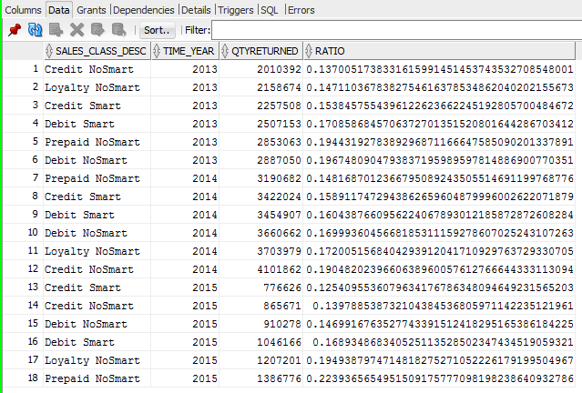

1. **AQ9**

SELECT Location_Name,W_Time_D.Time_Year,SUM(DAYSDIFF) AS SUMDAYSDIFF,

RANK() OVER(Partition By W_Time_D.Time_Year Order By SUM(DAYSDIFF) DESC) AS Rank,

DENSE_RANK() OVER(Partition By W_Time_D.Time_Year Order By SUM(DAYSDIFF) DESC) AS DenseRank

FROM BQ6,W_Time_D

WHERE W_Time_D.Time_Id = BQ6.Date_Ship_By

GROUP BY Location_Name,W_Time_D.Time_Year;

(27 rows)

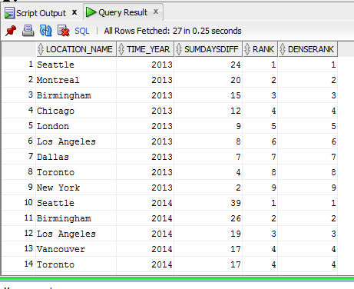

1. **AQ10**

SELECT Location_Name,W_Time_D.Time_Year,SUM(DAYSDIFF) AS SUMDAYSDIFF,Count(*) AS NoofJobs,

SUM(Quantity_Ordered - SumShipQty) / SUM(Quantity_Ordered) AS Delay_Rate,

RANK() OVER(Partition By W_Time_D.Time_Year Order By SUM(Quantity_Ordered - SumShipQty) / SUM(Quantity_Ordered) DESC) AS Rank

FROM BQ5,W_Time_D

WHERE W_Time_D.Time_Id = BQ5.Date_Promised

GROUP BY Location_Name,W_Time_D.Time_Year;

(27 rows)

